# Databases – Create or not create

## About:

If you do this lab you will be able to use almost all of your code in your final project if you are using a database to store your information. This lab will cover a few common things you will do with databases. You will detect if the database is created and if not create it and populate it with some data. You will also display the data that currently exists in the table. There is no GUI or user input required for this lab. You will use the same tables needed for the final project.

## Things to Consider:

* If your database already exists don’t overwrite it or repopulate it.
* Key to this is going to be to determine if the database is already created.
* One way to see if a database exists is try to connect to it without create keyword
* Your output should look like mine, all console output and describes what program is doing.
* We are going to test this by compiling your source and then running it twice as seen below.
* Most of the code to do this can be found in the CreateCoffeeDB source from the book.
* Do not drop the tables if the db is already created.
* Use methods when needed you will have at least addMediaTable, addOwnerTable, populateMediaTable, populateOwnerTable, and showTableData
* If you have a foreign key the order of the tables being created matters
* Make the IDs an auto incrementing int, see this [link](https://db.apache.org/derby/docs/10.0/manuals/develop/develop132.html)
* How do you make a field required in a database?

## The Challenge:

Make a java source file called Lab13LastNameFi.java. You need to detect if a “Lab13LastNameFiDB” is created. If it is created display the Media title, and the owner first name and last name. The Media table and Owner table are separate and described in the Entity Relationship Diagram below. All fields are required except the dates and the phone. If the database does not exist then create it and populate it with at least 3 owners and 4 media items. Be sure to give print statements that tell what your program is doing so it is easy for us to see, like in my output example. We will run your program two times as in example output below. Be sure you do not drop or try to recreate or repopulate the tables when they already exist.

## Sample Output:

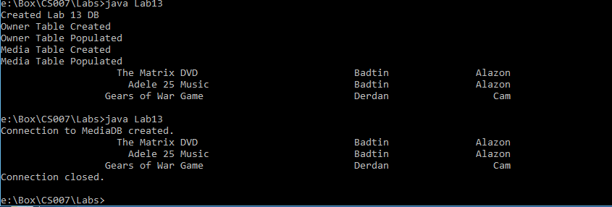

## Submission:

Submit only your Lab13LastNameFi.java file to Courseweb. Submission must be complete by 23:59:00 on the due date. No late submissions will be accepted by email.

## Grading:

4 – Does it compile and execute and show you are close

4 – Does it provide correct results and meet the requirements specified in this document

2 – Proper labeling, comments, followed submission instructions, and is readable.

Relationship Diagram: